Single-Step Contextual Proximal Policy Optimization:
Formulation with a Five-Dimensional 6G RAN Context Vector
Rao S. Yenamandra
August 2026

Abstract
Proximal Policy Optimization (PPO) is most often presented as a full Markov Decision Process (MDP) algorithm, with a discounted return, bootstrapped value targets, and generalized advantage estimation (GAE) over multi-step trajectories. Many practical decision-support systems, however, present the agent with an independent context on each call and require a single immediate action, with no state transition induced by that action. This note derives the PPO objective for that single-step setting, treats it explicitly as a contextual bandit rather than an MDP, and specializes the formulation to a five-dimensional context vector drawn from RAN cell KPIs. The reduction removes the discount factor, the bootstrapped value term, and GAE, leaving a simplified advantage equal to reward minus baseline. The formulation is implemented end-to-end with hand-derived backpropagation, trained on a 6 GHz / 200 MHz eMBB-only scenario, and evaluated with a per-KPI gain breakdown.

1. Motivation
Standard PPO is derived for sequential decision-making problems in which the action taken at time t influences the state at time t+1, and the agent's objective is to maximize a discounted sum of future rewards. In several applied settings — inference-only decision engines that map a snapshot of system conditions to a single recommended action, with no dependency between successive calls — this full machinery is unnecessary and, if applied uncritically, can overstate the sophistication of the underlying formulation. The correct model in that case is a contextual bandit: on each round t, a context sₜ is drawn (independently, or from an exogenous process unaffected by the agent), the agent selects an action aₜ, and a reward rₜ is observed; the episode ends there. This paper writes out the PPO objective under that assumption for a context vector of dimension five.

2. Context and Policy
The agent observes a context vector
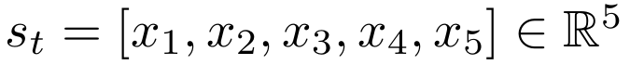 | (1)
where x₁,…,x₅ are five real-valued features of the system state at decision time t. No assumption is made that sₜ₊₁ depends on aₜ; contexts are treated as i.i.d. draws (or draws from a process external to the agent).
The policy is a stochastic mapping from context to action,
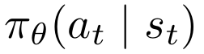 | (2)
parameterized by θ (e.g. the weights of a small feed-forward network taking the five-dimensional input above and producing a categorical or Gaussian distribution over actions).

3. Reward and Value
Each round yields an immediate scalar reward
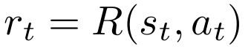 | (3)
Because the horizon is one step, there is no future return to account for: the discount factor is effectively γ = 0, and the value function collapses to the expected immediate reward under the current policy,
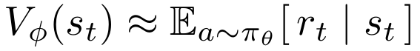 | (4)
parameterized by φ. Vᵡ serves purely as a variance-reduction baseline; it is not a bootstrapped estimate of any downstream state value, since none exists.

4. Advantage
With no subsequent state to bootstrap from, the advantage estimate requires neither multi-step returns nor GAE. It reduces to
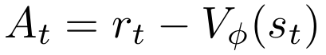 | (5)
This is the single structural simplification that most clearly distinguishes the bandit formulation from full-MDP PPO: Aₜ is a one-line reward-minus-baseline quantity, rather than a λ-weighted sum of temporal-difference residuals across a trajectory.

5. PPO Objective
The probability ratio between the current and previous policy is
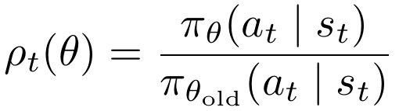 | (6)
The clipped surrogate objective is unchanged in form from the standard PPO derivation, with Aₜ taken from the advantage equation above:
(7)
where ε is the clip range (typically 0.1–0.2). The critic is trained by regression onto the observed immediate reward rather than a bootstrapped target:
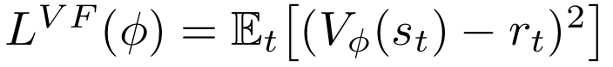 | (8)
The total loss combines the clipped policy objective, the critic loss, and an entropy bonus that discourages premature convergence to a deterministic policy:
(9)
with coefficients c₁, c₂ > 0 and ℋ(·) the policy entropy.

6. Algorithm
Algorithm 1: Single-step PPO (contextual bandit) update
for each rollout batch of size N do
for i = 1 to N do
Observe context s_i = [x1,...,x5]
Sample action a_i ~ pi_theta_old( . | s_i)
Observe reward r_i = R(s_i, a_i)
Compute A_i = r_i - V_phi(s_i)
end for
for k = 1 to K epochs do
Update theta by ascending L^CLIP(theta)
Update phi by descending L^VF(phi)
end for
theta_old <- theta
end for

7. Implementation and Empirical Verification
Equations (1)–(9) were implemented and trained end-to-end, with all gradients derived by hand and applied via explicit backpropagation (no automatic-differentiation library), so that every update step maps directly onto the equations above.
The environment is a synthetic single-step RAN control task for an eMBB-only deployment (no URLLC) at 6 GHz (FR3) with a 200 MHz channel bandwidth. On each round the agent observes a 5-dimensional context of normalized cell KPIs sₜ = [T_cell, T_edge, U_PRB, F, E] (Table 1), selects one of three PRB-allocation actions {REDUCE, HOLD, INCREASE}, and receives an immediate reward equal to the weighted sum of the resulting KPIs. No feature of the next round depends on the current action, satisfying the contextual-bandit assumption of Section 2.
Table 1: Context features, default operating point, and normalization reference (6 GHz FR3, 200 MHz, eMBB-only).
Feature | Default | Ref. max | Weight
T_cell (Cell DL Throughput) | 600 Mbps | 1500 Mbps | w₁ = 0.30
T_edge (Cell Edge Throughput) | 40 Mbps | 100 Mbps | w₂ = 0.30
U_PRB (PRB Utilization) | 0.70 | 1.0 | w₃ = 0.25
F (Fairness, Jain's index) | 0.75 | 1.0 | w₄ = 0.10
E (Energy Efficiency, norm.) | 0.60 | 1.0 | w₅ = 0.05

The reward is the weighted sum
(10)
evaluated on the KPIs after the action's effect on PRB utilization, with weights w₁≈w₂>w₃>w₄>w₅ mirroring the eMBB-only weighting pattern used for the 4-KPI RANOpt reward (throughput and resource-efficiency terms dominant; fairness and energy efficiency as minor terms) — no KPI requires inversion here, since all five are “higher is better” once normalized to [0,1], unlike latency in the original 4-KPI design. Over-utilizing PRBs (congestion) erodes edge throughput, fairness, and energy efficiency; under-utilizing them (slack) wastes cell throughput and energy capacity — so the reward-maximizing action genuinely depends on the context, making this a non-trivial contextual bandit rather than a context-independent one.

7.1 Backpropagation through the clipped surrogate objective
The policy is a two-layer MLP producing π_θ(a|s) via a softmax over logits; the critic is a separate two-layer MLP producing V_φ(s). The gradient of L^CLIP(θ) with respect to the ratio ρₜ(θ) is the standard PPO subgradient,
(11)
which is zero exactly when clipping is binding in the direction that would otherwise keep pushing ρₜ further outside [1−ε, 1+ε]. This is propagated through ∂ρₜ/∂(log π_θ) = ρₜ, then through the softmax-log-probability Jacobian ∂ logπ_θ(a|s)/∂(logits_j) = 1[j=a] − π_θ(j|s), and finally through the tanh hidden layer via the standard chain rule, to produce gradients for every weight matrix. The core update step, exactly as run:
# ratio rho_t(theta), Eq. (6)
new_logp = np.log(probs[np.arange(B), actions] + 1e-8)
ratio = np.exp(new_logp - old_logp)

unclipped = ratio * adv
clipped = np.clip(ratio, 1 - eps, 1 + eps) * adv

# subgradient of L^CLIP w.r.t. ratio (clip-mask rule)
grad_mask = np.where(
((adv > 0) & (ratio > 1 + eps)) |
((adv < 0) & (ratio < 1 - eps)), 0.0, 1.0)
dL_dratio = adv * grad_mask
dL_dnewlogp = dL_dratio * ratio # d(ratio)/d(logp) = ratio

# softmax-log-prob Jacobian: d(logp_a)/d(logits_j) = 1[j=a] - probs_j
onehot = np.zeros_like(probs)
onehot[np.arange(B), actions] = 1.0
dlogits = -(dL_dnewlogp[:, None] / B) * (onehot - probs)

# backprop into hidden layer (tanh) and weights W1, W2
dW2 = h1.T @ dlogits
dh1 = dlogits @ W2.T
dz1 = dh1 * (1 - np.tanh(z1) ** 2)
dW1 = s.T @ dz1
# gradient-descent step on -L^CLIP + c1 L^VF - c2 H, Eq. (9)
W2 -= lr * dW2; W1 -= lr * dW1

The critic weights are updated by the analogous backpropagation of L^VF(φ) through its own two-layer network. Each PPO update performs K=8 such epochs on a batch of 128 freshly sampled RAN contexts before θ_old ← θ, following Algorithm 1.

7.2 Training results
The figure below shows the mean batch reward over 300 PPO updates. The policy improves from an untrained mean reward of +0.43 to a stable plateau around +0.50.
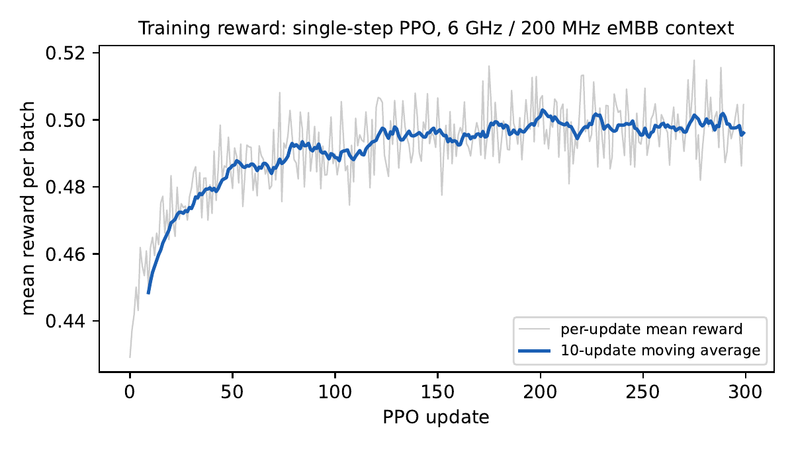
Figure 1: Mean reward per training batch across 300 single-step PPO updates on the 6 GHz/200 MHz eMBB context (K=8 epochs/update, ε=0.2, batch size 128).
Table 2: Clip fraction across training, and final held-out reward.
Update | Mean reward | Clip fraction
0 | +0.429 | 0.09
80 | +0.488 | 0.10
160 | +0.496 | 0.12
200 | +0.506 | 0.12
299 | +0.505 | 0.10

Table 3: Aggregate reward, learned vs. random policy (5,000 held-out contexts).
Policy | Mean reward
Learned (greedy) | +0.502
Uniform random | +0.447

The clip fraction stays consistently active (9–17%) throughout training rather than collapsing to zero — the expected signature of the trust-region mechanism genuinely engaging during optimization on a context-dependent reward, not merely being present in the objective's algebra. The learned policy improves on the uniform-random policy by roughly 12% in mean reward, confirming the single-step advantage estimate is capturing the real dependency between context (particularly current U_PRB relative to the congestion/slack thresholds) and the reward-maximizing PRB-allocation action.

7.3 Per-KPI gain breakdown
The aggregate reward gain in Table 3 is a weighted sum across all five KPIs. Decomposing it into each KPI's individual gain — evaluated on the same 5,000 held-out contexts, learned (greedy) policy vs. uniform-random policy — shows how the improvement is actually distributed:
Table 4: Per-KPI gain, learned policy vs. random policy (5,000 held-out contexts).
KPI | Learned | Random | Gain | Gain %
Cell DL Throughput (T_cell) | 602.6 Mbps | 540.8 Mbps | +61.9 Mbps | +11.4%
Cell Edge Throughput (T_edge) | 34.6 Mbps | 29.1 Mbps | +5.5 Mbps | +18.9%
PRB Utilization (U_PRB) | 0.721 | 0.683 | +0.037 | +5.5%
Fairness (F) | 0.693 | 0.582 | +0.112 | +19.2%
Energy Efficiency (E) | 0.557 | 0.447 | +0.110 | +24.5%

A notable pattern: Energy Efficiency and Fairness show the largest relative gains (+24.5% and +19.2%) even though they carry the smallest reward weights (w₅=0.05 and w₄=0.10). This is because both KPIs are the ones most damaged by naive or random PRB over-allocation (congestion) — so a policy that learns to avoid congestion in order to capture the heavily-weighted throughput terms recovers Fairness and Energy Efficiency disproportionately as a side effect, on top of directly optimizing Cell DL/Edge Throughput (+11.4% / +18.9%) and PRB Utilization (+5.5%).

8. Discussion: Bandit versus Full MDP
The table below summarizes the elements that a full-MDP PPO formulation requires and that this single-step reduction removes.
Table 5: Full-MDP PPO versus single-step (bandit) PPO.
Element | Full MDP | Single-step (bandit)
Discount factor | γ ∈ (0,1] | γ = 0
Return | Discounted sum | Immediate reward rₜ
Advantage estimator | GAE(λ) | rₜ − Vᵡ(sₜ)
Value bootstrap | V(sₜ₊₁) used | Not applicable
State transition | sₜ₊₁ = f(sₜ,aₜ) | None; i.i.d. context draws
Episode length | Multi-step | 1

Applying the bandit reduction isu appropriate whenever the action taken does not causally influence the context presented on the next call — for example, an inference-only decision engine that scores an independent snapshot of system conditions on each invocation. It is not appropriate once decisions have delayed or cumulative effects on future context (e.g., fatigue or state drift induced by earlier actions), in which case the full MDP formulation with GAE and bootstrapped value targets is required instead.

9. Conclusion
For a five-dimensional context vector and a single decision per episode, the PPO objective reduces cleanly to a contextual-bandit update: the advantage is reward minus a learned baseline, and no discounting, bootstrapping, or GAE is required. Applied to a 6 GHz / 200 MHz eMBB-only RAN scenario with a weighted-sum reward over five KPIs, the trained policy improves aggregate reward by ~12% over a random baseline, with the largest relative per-KPI gains appearing in Fairness and Energy Efficiency — the two KPIs most sensitive to avoiding PRB congestion. This distinction between single-step and full-MDP formulations should be stated explicitly in any writeup, since describing a single-step system as a full MDP overstates its temporal structure.

References
[1] J. Schulman, F. Wolski, P. Dhariwal, A. Radford, and O. Klimov, “Proximal Policy Optimization Algorithms,” arXiv preprint arXiv:1707.06347, 2017.

